Entity Relationship Diagram

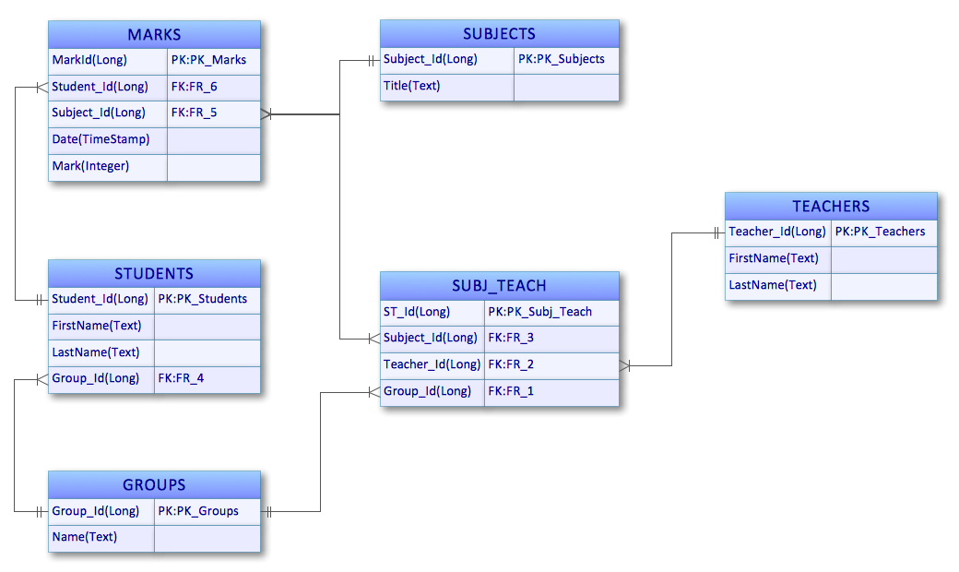

Figure : ERD

*Note: this is just an example. Replace it with appropriate diagrams*